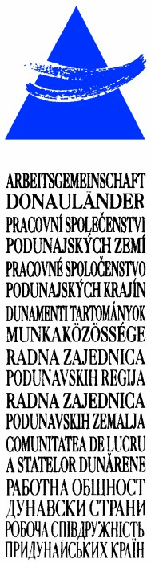
LAD1-IE-ED-4/045-2017
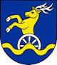
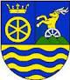
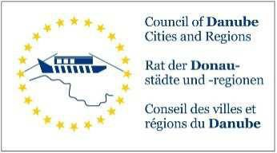

ARBEITSGEMEINSCHAFT DONAULÄNDER
WORKING COMMUNITY OF THE DANUBE REGIONS
27. Sitzung der Arbeitsgruppe der Leitenden Beamten
27th Meeting of the Working Group of Senior Officials
24. Konferenz der Regierungschefs
24th Conference of Heads of Government
12. Oktober 2017, 10.30 bis 13.00 Uhr
12th October 2017, 10.30 a.m. to 1.00 p.m.
Wellness Hotel Danubius Health Spa Resort Esplanade****
Conference room: „Palace Ballroom“
921 29 Piestany, Kúpeľný ostrov, Slovak Republic

https://www.danubiushotels.com/sk/najdi-hotel-piestany/danubius-health-spa- resort-esplanade
https://www.danubiushotels.com/sk/najdi-hotel-piestany/danubius-health-spa- resort-esplanade/mapa-a-doprava

P R O G R A M M
P R O G R A M
10.30 – 13.00 Uhr Konferenz der ARGE Donauländer
Wellness Hotel Danubius Health Spa Resort Esplanade****
Konferenzraum: „Palace Ballroom“
921 29 Piestany, Kúpeľný ostrov, Slovak Republik
10.30 a.m. – 1.00 p.m. Conference of the Working Community of the Danube Regions
Wellness Hotel Danubius Health Spa Resort Esplanade****
Conference room: „Palace Ballroom“
921 29 Piestany, Kúpeľný ostrov, Slovak Republik
13.00 – 14.30 Uhr Mittagessen
1.00 – 2.30 p.m. Lunch
14.30 Uhr Ende des Termins
2.30 p.m. End of the meeting

