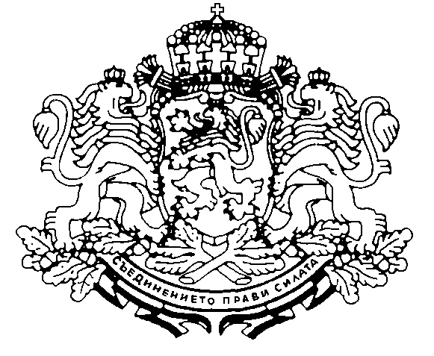

GOVERNOR RUSE REGION

Bulgaria, 7000 Ruse, 6 Svoboda sq., Tel. + 359 82 812 223, Fax + 359 82 820 092, e-mail: governor@rousse.spnet.net

Program of the international symposium
“Potential to alternative tourism development – a Danube regions’ competitive advantage”
23rd – 24th June 2008, Regional Administration Ruse, Hall №1 (6, Svoboda sq.)

23rd June 2008 (Monday)
10.30 Official opening
- Mariya Dimova – Governor of Ruse Region and President of the Consultative Council on Danube Issues
- Bilyana Raeva – Member of the European Parliament
- Anelia Krushkova – President of the Bulgarian State Agency for Tourism
- Peter de Martin – Manager of the Working Community of the Danube Regions
- Prof. Gerhard Skoff – President of the International Tourist Commission “The Danube” (to be confirmed)
11.00 Presentation of the state policy regarding alternative tourism development in Bulgaria
- Representative of the State Agency for Tourism
11.30 Discussion
12.00 Lunch break
13.30 Projects and good practices in the sphere of alternative tourism
- Presentation of tourist projects implemented by the Working Community of the Danube Regions
- Peter de Martin – Working Community of the Danube Regions
- Presentation of the project “By bike along the Danube”
- Hristina Georgieva – World for All Association
- Presentation of the programs “Green Corridors” and “Green Danube”
- Lyubomira Kolcheva – Bulgarian Environmental Partnership Foundation
- Presentation of the project “Creation and promotion of cross-border cultural itinerary: ‘From the Medieval complex of Ivanovo village through the orthodox temples of Ruse and Giurgiu to the monastry of Comana village’”
- Lili Gancheva – Euro-Region Danubius Association
  - Coffee-break
16.00 Discussion

24th June 2008 (Tuesday)
10.00 Summary of the outcomes of the previous day
10.15 Presentation of the funding opportunities for tourist projects in the framework of the Operational Program “Regional Development”
- Daniela Yordanova – Chief expert in the Department “North Central Region of Planning”, DG “Programming and Regional Development”, Ministry of Regional Development and Public Works
10.30 Presentation of the funding opportunities for tourist projects in the framework of the Rural Areas Development Program
- Representative of the Ministry for Agriculture and Food
10.45 Presentation of the funding opportunities for tourist projects in the framework of the Operational Program “Cross-Border Cooperation”
- Tamara Kuleva – Head of Department “North Central Region of Planning”, DG “Programming and Regional Development”, Ministry of Regional Development and Public Works
11.00 Presentation “Danube Guide”
- Dr. Nikolay Nenov – Director of Ruse Regional Historical Museum
11.30 Discussion
12.00 Lunch break
13.00 Press-conference

