Representation of the State of Baden-Württemberg Brussels, 21 April 2008
to the European Union
Rue Belliard 60-62
1040 Bruxelles
Christian Urban
Phone: 02-741.77.62
Fax: 02-741.77.09
christian.urban@bruessel.bwl.de

Fifth preparatory meeting for the Danube conference in 2008
on 4 April 2008

Participants: see attached list

Minutes

I. Evening Event, 06.10.2008

The participants agreed on the following title for the evening event: “Die Donau: Fluss der europäischen Zukunft”, “The Danube: River of the European Future”.

The program is planned as follows:

20h00 Aperitif, opportunity for talks and a round-tour through the presentations of
the Danube partners, visit of the “Danube market”

21h00 Official Opening of the Danube Conference 2008
Contributions:

• Günther H. Oettinger MdL, Minister President of Baden-Württemberg
(confirmed)
• Stjepan Mesić, President of Croatia (confirmed)
• Danuta Hübner, Member of the European Commission (confirmed)
• Ružica Djindjić, President of the Djindjić Foundation (confirmed)
• Péter Esterházy, Hungarian author (tbc.)
• Ivo Gönner, Mayor of the city of Ulm (confirmed)
• Prof. Dr. Wolfgang Reinhart MdL, designated Minister of the State Ministry
and for European Affairs of the State of Baden-Württemberg (confirmed)

22h00 Official round-tour through the presentations of the Danube partners

Followed by a reception with culinary specialties of the Danube region

If there are further ideas or requests for possible speakers, the Representation of Baden-Württemberg will be happy to include them into the program.

Every participating country, region or region will present itself with a stand, presenting local and regional projects, culture and typical food. This shall create an atmosphere of a kind of a “Danube market” with a variety of attractions, underlining the potential and diversity of the Danube region. In order to coordinate those presentations, the participants were asked to filled out the attached questionnaire and to send it back to the Representation of Baden-Württemberg before next meeting (16 May).

II. Plenary Sessions and Workshops, 07.10.2008

The participating regions, countries and cities are asked to find and attract possible speakers and contributors for the workshops. Attached you will find current program drafts for all three workshops which can be completed with your ideas. Furthermore, it would be important to identify questions and topics to be addressed in the course of each workshop. The Representation of Baden-Württemberg needs feedback on this issue as soon as possible. Moreover, all participants are asked to declare in which workshop they will be participating by mid June at the latest.

The draft program for 07.10.2008:

Plenary Session I, 07.10.2008

09h00 Registration, coffee

09h30 Plenary Session I in the Europasaal of the Representation of Baden- Württemberg.

Contributions

• Dr. Erhard Busek, Coordinator of the Stability Pact for South
Eastern Europe (confirmed)
• Ján Figel’, Member of the European Commission (tbc.)

Workshops, 07.10.2008

The following three topics have been chosen for in depth-discussions by all participating countries, regions and cities:

Workshop A: “Infrastructural Area Danube”, including Trans-European Networks
- will be held at the Goethe-Institute
- Head: Sergiy Kriuchkov, Mission of Ukraine to the EU
Workshop B: “Economy and Trade Area Danube”
- will be held at the Representation of Baden-Württemberg to the EU
- Head: Richard Arnold, Representation of Baden-Württemberg to the EU
Workshop C: “The Lisbon Process and the Danube Region”
- Will be held at the embassy of the Federal Republic of Germany to the
Kingdom of Belgium
- Head: Biserka Sladovic, Mission of the Croatia to the EU

10h30-
12h30 Workshops with presentations and contributions

Plenary Session II, 07.10.2008

13h00 Plenary Session II in the Europasaal of the Representation of Baden- Württemberg

Contributions

• Ivo Gönner, Mayor of the city of Ulm (confirmed)
• Klaus Werner Johannis, Mayor of the city of Sibiu (confirmed)
• Leonard Orban, Member of the European Commission (tbc.)

14h00 Invitation to lunch

III. Final declaration

The final declaration shall be entitled “The Danube - River of the European Future” and will be handed out unsigned at the end of the Danube conference. In this context, the Representation of Baden-Württemberg introduced the director of the European Institute for cross-border co-operation in Kehl, Dr. Joachim Beck, who will be involved in this process.

IV. Miscellaneous

The Representation of Baden-Württemberg will approach the Committee of the Regions in order to make the Danube conference a so-called “fringe-event” of the Open Days 2008.

Encls: - List of participants of 4 April
- Danube outline
- List of participants in the Danube-Conference
- Questionnaire and information sheet on presentations, floor plan of the
Representation of Baden-Württemberg to the EU

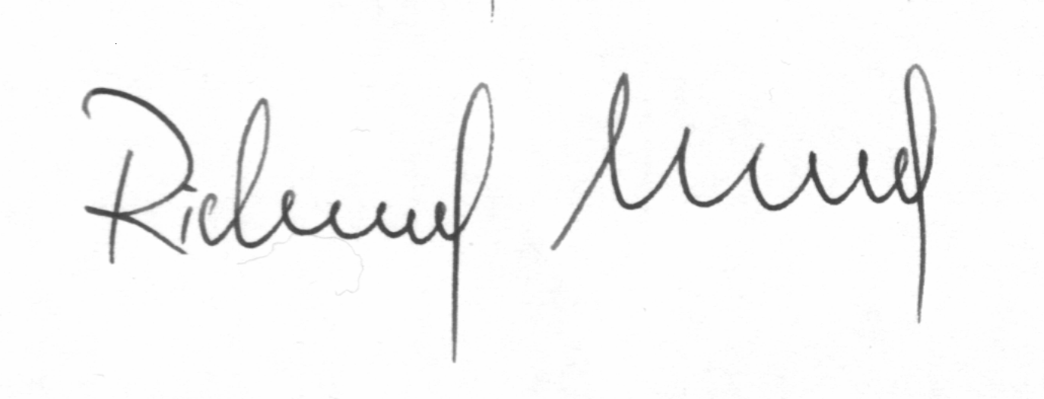Signed and approved

Richard Arnold
21.04.2008

