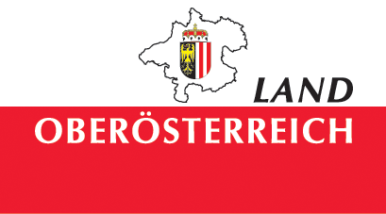

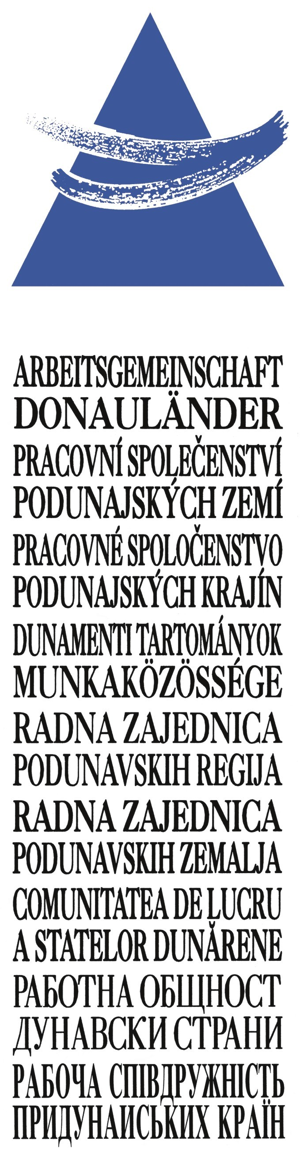

L i n z 2 0 0 9
Oberösterreich

Working Community of the
Danube Regions
Linz 2009 Upper Austria

Conference of the Regional Leaders
June 29, 2009

S U M M A R Y
of the decisions stated in the
Final Declaration of the Conference of the ARGE Donauländer

Sustainably Shaping the Future of the Danube Region

Sustainability
- welcoming the cooperation within the framework of the Agenda21 process
- support of the initiation of a sustainability strategy that is to be developed within the framework of the EU strategy for the Danube region in the coming years

European Union
support of
- the work of the cross-party group "Danube Region" within the Committee of the Regions
- the results of the Danube Summit that was hosted by Baden-Württemberg on May 6, 2009 in Ulm
- the initiatives of the European Parliament, the European Council, and the European Commission to further the integration in the Danube region and to develop a EU strategy for the Danube region
- the change of the Stability Pact for South Eastern Europe into a regional cooperation network (Regional Cooperation Council, RCC) working under the aegis of the South East European Cooperation Process (SEECP).

- welcoming the announcement of EU Regional Commissioner Danuta Hübner in the Session of the Committee of the Regions on October 8, 2008 in Brussels, to have a EU strategy for the Danube region developed
- welcoming the decision of the European Council from June 18/19, 2009 in Brussels for a revaluation of the Danube region on a European level and for a mandate to develop a European strategy for the Danube region with the same attention as is given to the Mediterranean Union and the Baltic Sea Region
- support of the development of a EU strategy for the Danube region
- support of the rapid admittance of the Republic of Croatia into the European Union
- support of the efforts of countries from the Western Balkans to join the European Union

Economy
- confession to a social and ecologically sustainable market economy
- declaration that it is the highest objective to cushion the effects of the financial and economic crisis as much as possible
- confirmation of the conviction that if the crisis will be seen as a chance for progress, the Danube region will develop positively
- confirmation of the conviction that cooperation and an increase in quality also increase the added value along the Danube
- pursuit of a common goal: the development of the Danube region into a common economic area
- welcome and support of the suggestion of the expert group led by Dr. Edmund Stoiber to reduce the reporting duty for small businesses
- welcoming the trans-border cooperations in the Danube region and the successful realization of joint projects in tourism
- welcoming the existing cross-border cooperations of the chambers and organizations as an example for sustainable economic management
- suggestion of the abolition of administrative barriers especially for small and medium-sized businesses as a relief for working and trading in a cross-border context
- support of the liberalization of visa requirements for countries of the Western Balkans
- welcoming and support of trans-border and trans-national projects of economic and social protagonists and advocates
- support of the enhancement of the instrument of the EVTZ also for the bilateral cooperation with third states to lead the states, regions, an municipalities of the Danube region outside the European Union to it

Traffic
- welcoming the infrastructure projects of the European Commission TEN 17 (axis Paris – Bratislava), TEN 18 (axis Rotterdam – Constanta) and TEN 22 (axis Nuremberg – Constanta) as an important contribution to the sustainable development
- demand of an integrated, sustainable, and intelligent mobility and traffic concept to be able to manage the future flows of traffic with special consideration of the Danube waterway

Science and research
- welcoming initiatives to strengthen research activities by closer cooperation and networking in the Danube region as well as initiatives in the field of innovation management
- support of the project of the Working Community to establish an online database that offers an overview over the existing institutions in the Danube region, and invitation to the institutions to cooperate on this project.

Youth and Education
support of
- the expansion of the European dimension of general education
- the alleviation of transnational access to education in Europe and especially in the Danube region
- the promotion of equal opportunities in all fields of education
- the promotion of languages (especially the languages in the Danube region and in the European Union) and an intercultural dimension of teaching
- the promotion of cooperation and mobility an the field of education by abolishing mobility barriers
- and the promotion of innovation in the field of developing pedagogical practices

welcoming and support of
- projects with the purpose to make the UN decade and its goals visible and understandable in the Danube area
- projects that focus on sustainability and creativity as an engine for innovation and crucial factor for development of personal, vocational, social, and entrepreneurial competences

Culture
- appreciation of the traditional cultural and historical ties
- support of the rapid acknowledgement of the Danube Limes as part of the UNESCO World Cultural Heritage
- welcoming the cooperation with the Working Community "Straße der Kaiser und Könige", the oldest international tourism association in the middle of Europe
- suggestion of a connection of the European Cultural Capitals 2010 – Essen and the Ruhr area, Pécs, and Istanbul – through cultural events and so to build a "European cultural mile" and to make the Danube the focal point of all Europe
- welcoming and support of the European Year of Creativity and Innovation as well as the cultural diversity and the cultural dialogue
- suggestion of a dialogue between the economy and artists, designers, and other creatives, so as to utilize their creativity and innovation skills for the whole society in the sense of the Cultural Agenda of the European Union
- welcoming the diversity of the media and the quality journalism of the local and regional media in the Danube region which are a guarantee for this diversity
- welcoming the initiative of the Working Community to establish an online database that offers an overview over the existing institutions and media in the Danube region, and invites the cultural institutions and media to cooperate on this project

Environment and Climate protection
- resolve on a partnership for joint action against climate change
- confirmation that the EU emissions trade has to guarantee EU wide harmonized and fair global competition conditions
- welcoming the exchange of experiences and know-how and supports innovative projects in the Danube region

Energy security
Welcoming
- events connected with this topic
- dialogues about increasing energy efficiency and the amount of renewable energy
- dialogues about scientific and economic know-how transfer

- support of the modernization of the existing hydroelectric power plants, especially the small ones
- welcoming the construction of new gas pipelines that will contribute to a greater diversity of supply with gas and therefore to a greater energy security

